**COMCAST INTERNET-AT-HOME OFFER FOR FAMILIES IN NEED**

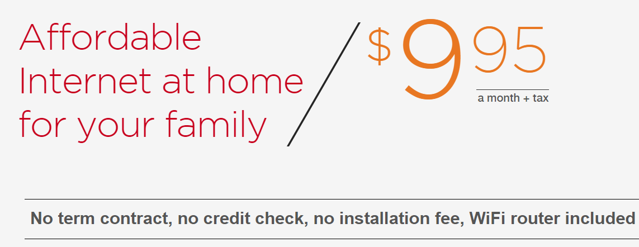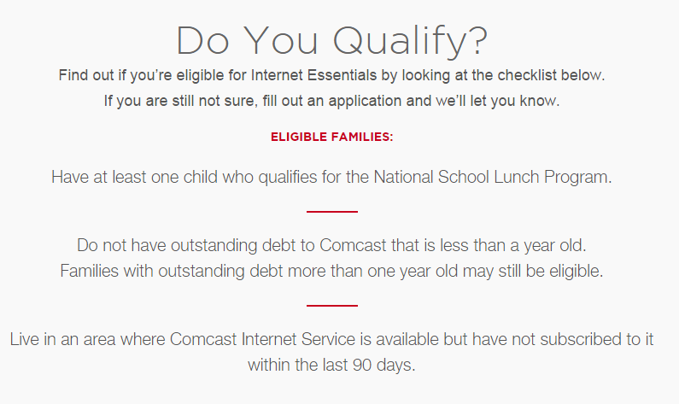

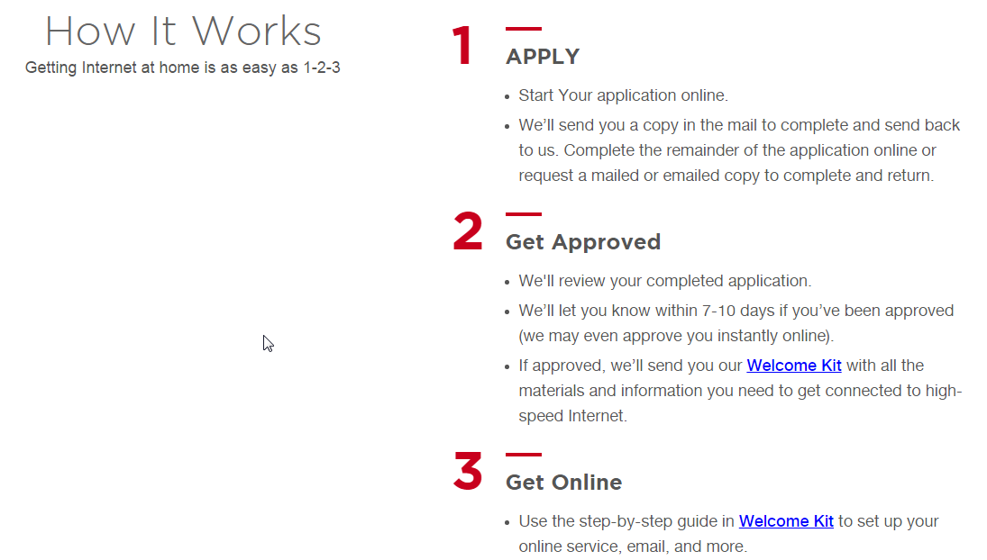

**VISIT <https://internetessentials.com/> TO APPLY TODAY**